Q.1) .Write an algorithm to find the area of the triangle

Step 1: Start.

Step 2 : Read a,b,c.

Step 3: s=(a+b+c)/2.

Step 4 : Area = (s(s-a)(s-b)(s-c))1/2

Step 5 : Print Area.

Step 6: Stop.

Q.2) Draw a flowchart for adding the integers from 1 to 100 and to print the sum.

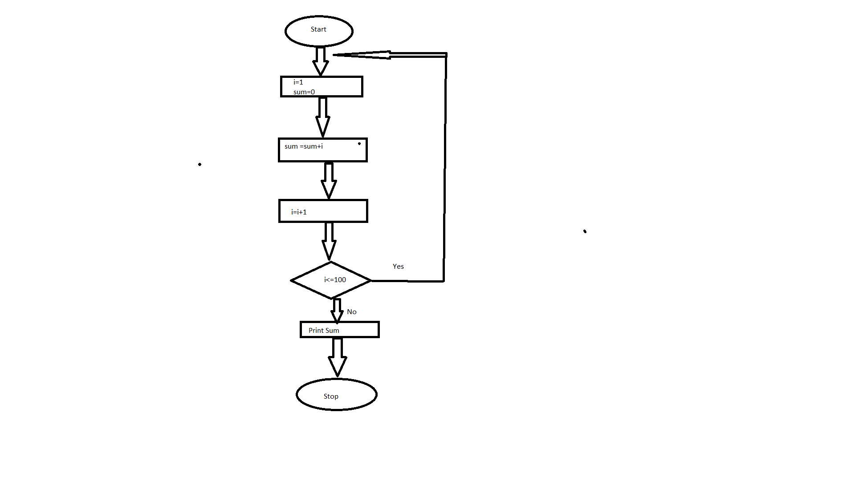

Q.3).Write a pseudo code to perform the basic arithmetic operations.

1. Start

2. Enter value of the variable (addend) X

3. Enter value of the variable (addend) Y

4. Calculate Z (Z = X + Y)

5. Display result of addition, value of Z on the monitor with the message "The sum of X and Y is:"

6. Ask the question "Do you want to re-start the program <Y / N>?" and set value to the response variable ANSWER

7. If the ANSWER is "Yes," go to Step 1

8. If the ANSWER is "No," go to Step 9

9. End

4. Draw a flowchart to find the factorial of given positive integer N.

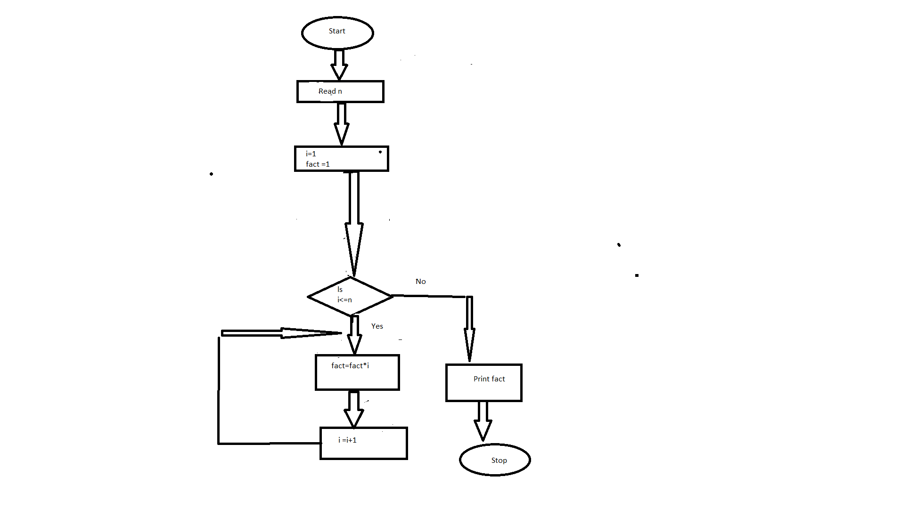

5. Develop a flowchart to illustrate how to make a Land phone telephone call.

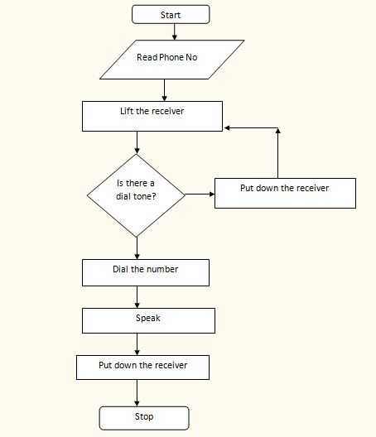

6. Write an algorithm to calculate the simple interest using the formula.

STEP 1: START

STEP 2: READ THE THREE INPUT VALUES i.e. PRINCIPAL AMOUNT, RATE, TIME

STEP 3: CALCULATE SIMPLE INTEREST USING FORMULA, SI = (PRINCIPAL AMOUNT\*RATE\*TIME)/100

STEP 4: PRINT THE SIMPLE INTEREST

STEP 5: END